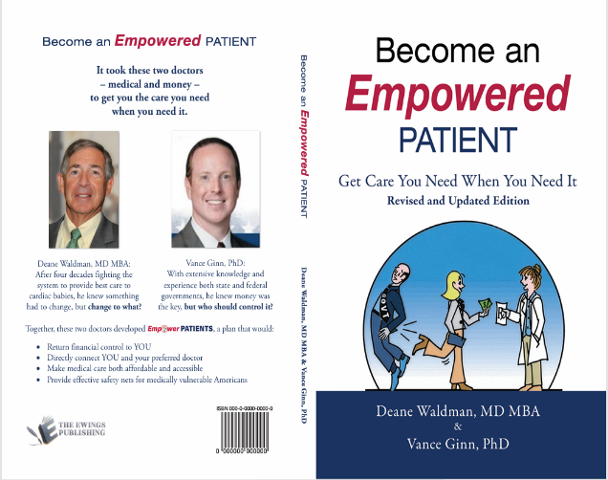
A New Book Encourages Patients to Take Control of Their Healthcare — Now Available in English and Spanish
For many people, healthcare has become increasingly complicated. Long wait times, rising costs, and confusing insurance requirements can leave patients feeling powerless at the very moment they need clarity the most.
A newly updated book, Become an Empowered Patient: Get the Care You Need When You Need It, by pediatric cardiologist Dr. Deane Waldman, MD, MBA, and economist Dr. Vance Ginn, PhD, explores why so many individuals struggle to access care — and what they can do to get the care they need when they need it!
Now released in both English and Spanish editions, the book aims to Dispel healthcare myths, Connect us to each other, and Control our own money, not some faceless, unaccountable third-party.

Combining medicine and money
It was the unique combination of experience and talents of these two doctors that produced the way out of our healthcare nightmare. Dr. Waldman brought four decades practicing medicine in (and around) the system. Dr. Ginn added his in-depth economic expertise and first-hand knowledge of government inner workings. Together they are proud to announce a “cure” for Patient Healthcare: the Empower Patients Initiative.
The book answers three questions we all ask ourselves:
- Why are we spending more (than anyone else) and getting less (care)?
- I have insurance – why is it so hard to get medical care?
- Most important: What should I do when I or my family needs medical care?
By addressing these questions, the authors aim to help readers satisfy their medical needs by taking charge of their own healthcare spending.

A Focus on Patient Empowerment
Rather than presenting technical policy arguments, the book focuses on the readers concerns and shows the answer is patient empowerment. It encourages readers to question accepted wisdom and talk openly with each other. Most important, Americans should demand that their elected officials, both state and federal, return control of their own hard-earned dollars to them.

Pre-launch readers gave  and wrote:
- “Reads like a long conversation that patients wish they could have had with their doctors”
- “Focus stays on people ... not policy”
- “Doesn’t rely on fear to make its point”
- “How patient-centered the entire argument is!”
- “Doesn’t talk down to people”
- “Offers clear framework for how care could be more personal, affordable, and humane.”

Expanding Access Through Language
The addition of a Spanish edition – Sé un Paciente Empoderado – reflects a growing recognition that language barriers can significantly affect healthcare understanding and outcomes. Providing resources in multiple languages allows more families to engage confidently with medical information and decision-making.

A Timely Conversation
Healthcare decisions often occur during vulnerable moments — illness, uncertainty, or crisis. Feeling informed and confident during those moments can make a meaningful difference for patients and families.
Become an Empowered Patient returns healthcare to its first and highest priority – the patient. The message of this little book may be unwelcome to certain special interests, but it will be warmly and gratefully greeted by We the Patients.

Learn More
Website: https://www.deanewaldmanbooks.com/
Facebook: https://www.facebook.com/profile.php?id=61587546494758
Twitter (X): https://x.com/DrDeaneW
Book Release: April 2026

